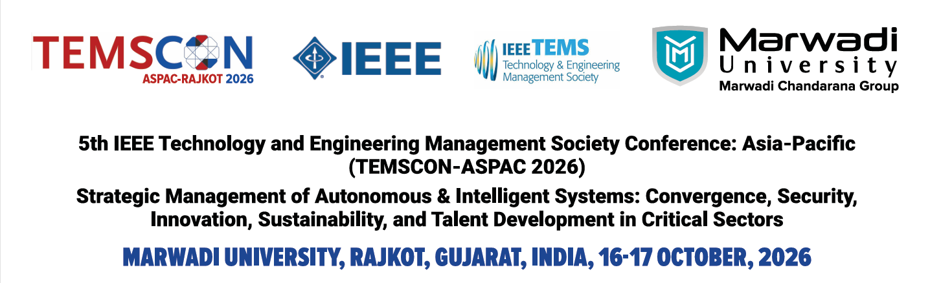Special Session Proposals

The 2026 IEEE Technology and Engineering Management Society (TEMS) Conference Asia Pacific — TEMSCON-ASPAC 2026 (Conference Record #69489) is a flagship conference of the IEEE Technology and Engineering Management Society. TEMSCON continues to highlight cutting-edge developments and practices of technology and innovation management in today’s rapidly evolving business and societal environments. In 2026, TEMSCON-ASPAC adopts the theme: “Strategic Management of Autonomous & Intelligent Systems: Convergence, Security, Innovation, Sustainability, and Talent Development in Critical Sectors.”
Hosted at Marwadi University, Rajkot, Gujarat, India, on 16-17 October, 2026, the conference brings together scholars, practitioners, innovators, and industry leaders from across Asia-Pacific and beyond. The program includes keynote addresses, research paper presentations, an Industry Forum, and discussions on the opportunities and challenges of deploying intelligent systems in healthcare, defense, aerospace, smart manufacturing, and Industry 5.0.
The 2026, TEMSCON-ASPAC invites proposals for Special Sessions. Special sessions complement the regular technical program by highlighting new and emerging research topics or innovative applications of established approaches. The topic of a special session proposal should be timely and compelling to the theme of conference.
The goal of special sessions is to provide a forum for contributions that are highly specialized in some particular theme, focused on new topics or innovative applications of established approaches. A special session consists of four to six papers, which, for example, addresses a particular theme or consist of work done in some particular international project. Prospective organizers are invited to submit proposals for special sessions by April 30, 2026
Proposals for special sessions are required to contain the following information:
- Title for the proposed special session
- One page summary of the special session including its motivation and goals
- List of prospective authors who will submit papers to the special session
- List of organizers (names, affiliations and short bio).
There is a two-page limit for each proposal. Selected special sessions will be announced through the conference and will be open for submission to everyone. (Note that all papers will be subject to the same peer review process as for regular papers.)
Proposals for special sessions must be sent to temscon.aspac@gmail.com. All papers will be peer-reviewed and will appear in the conference proceedings. The organizers will be Track Chairs (TC) for the proposed special session track. They are also responsible to assign reviewers and make judgment of the submitted paper for the special session. Papers co-authored by the special session organizers will be managed by other TCs to avoid conflicts of interest. Please note that special session papers will be subject to the same rigorous review process, which applies to regular papers not included in special sessions. The minimum number of papers per special session is four. If less than four papers submitted to a special session are accepted based on the reviewing process, the Program Committee reserves the right to re-assign these accepted papers to regular sessions.
Special Session Proposal need to be sent to: temscon.aspac@gmail.com

