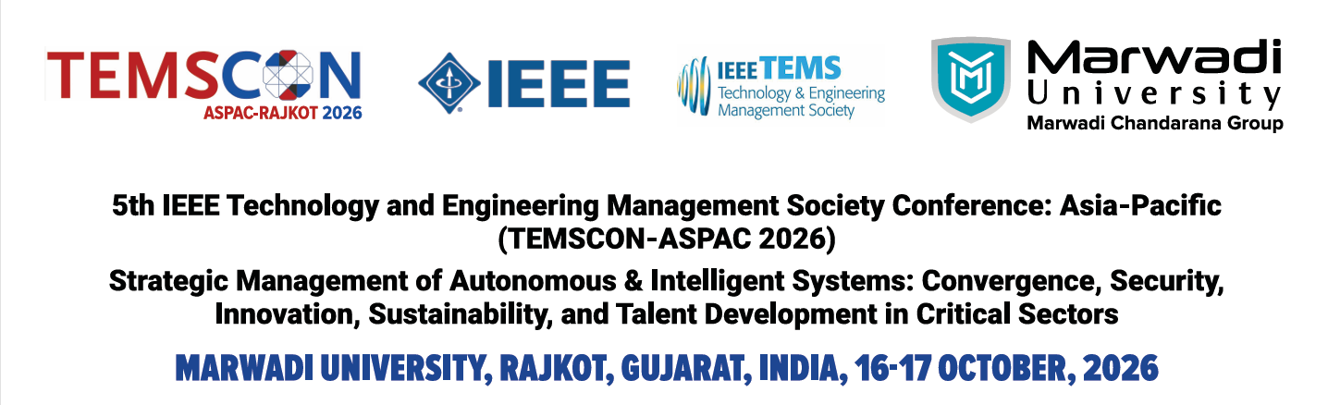Tutorial Proposals

The 2026 IEEE Technology and Engineering Management Society (TEMS) Conference Asia Pacific — TEMSCON-ASPAC 2026 (Conference Record #69489) is a flagship conference of the IEEE Technology and Engineering Management Society. TEMSCON continues to highlight cutting-edge developments and practices of technology and innovation management in today’s rapidly evolving business and societal environments. In 2026, TEMSCON-ASPAC adopts the theme: “Strategic Management of Autonomous & Intelligent Systems: Convergence, Security, Innovation, Sustainability, and Talent Development in Critical Sectors.”
Hosted at Marwadi University, Rajkot, Gujarat, India, on 16-17 October, 2026, the conference brings together scholars, practitioners, innovators, and industry leaders from across Asia-Pacific and beyond. The program includes keynote addresses, research paper presentations, an Industry Forum, and discussions on the opportunities and challenges of deploying intelligent systems in healthcare, defense, aerospace, smart manufacturing, and Industry 5.0.
A proposal of two hours tutorial sessions focuses on a specific theme of Technology and Engineering Management aspects interest that can attract high-quality submissions. Mainly researchers, technologists, engineers, scientists, investors, representatives from NGOs, government officials, academia and the industry personnel to come together, share their experiences and interact closely with each other to identify, create and advance technology for the benefit of the humanity.
Submission Deadline: April 30, 2026
Acceptance: May 15, 2026

Please follow the format given below:

Include the following information:
Title of the Tutorial: _________________________________________________________
Significance and timeliness: _________________________________________________________
Complete contact details and a short bio of the Tutorial organizers: ________________________
Planned format for the two hours tutorial sessions with expected paper submission volume: _______
History of the Tutorials that have been conducted (if applicable): _____________________________
Target Audience
University Students, Government officials, investors and technologists.

Comments:
Any other comments: ____________________________________________________

Tutorial Proposal need to be sent to: temscon.aspac@gmail.com

