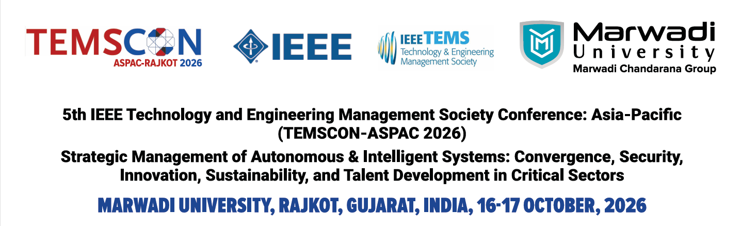

Workshop Proposals

The 2026 IEEE Technology and Engineering Management Society (TEMS) Conference Asia Pacific — TEMSCON-ASPAC 2026 (Conference Record #69489) is a flagship conference of the IEEE Technology and Engineering Management Society. TEMSCON continues to highlight cutting-edge developments and practices of technology and innovation management in today’s rapidly evolving business and societal environments. In 2026, TEMSCON-ASPAC adopts the theme: “Strategic Management of Autonomous & Intelligent Systems: Convergence, Security, Innovation, Sustainability, and Talent Development in Critical Sectors.”
Hosted at Marwadi University, Rajkot, Gujarat, India, on 16-17 October, 2026, the conference brings together scholars, practitioners, innovators, and industry leaders from across Asia-Pacific and beyond. The program includes keynote addresses, research paper presentations, an Industry Forum, and discussions on the opportunities and challenges of deploying intelligent systems in healthcare, defense, aerospace, smart manufacturing, and Industry 5.0.
All enthusiastic parties are invited to submit a proposal for a workshop aligned with the mission and the objectives of the conference on or before May 15, 2023 to temscon.aspac@gmail.com
Submission Deadline: April 30, 2026
Acceptance: May 15, 2026
Please follow the format given below:
Submitter Details:
Applicant’s Name: _________________________________________________
Applicant’s Email Address: _________________________________________________
Contact number: _________________________________________________
IEEE member? (Y/N): _________________________________________________
IEEE Membership Number: _________________________________________________
IEEE Section: _________________________________________________
Institute: _________________________________________________
Country: _________________________________________________
Organizers Details:
Please list all organizers, with the contact person at top.
For each person, please provide: name, email, affiliation, URL, and career state [PhD student | post-doc | professor | industry | …]

Workshop Details:
Workshop Title: ___________________________________________
Duration (specify full day | half day): ___________________________________________
How best would you describe your workshop? * (max 100 words): _________________
Impact to the Society and the target audience * (max 200 words): _________________
Scientific Goals ― (max 200 words): ___________________________________________
Please describe the goals you pursue by organizing this workshop. Include a description of the urgency or need that you are addressing with the workshop. Please consider that the format of the workshops should be well-suited with the theme of the conference.
Initial budget of the workshop: ___________________________________________
Participation (max. 100 words): ___________________________________________
Please describe how you will ask for participation in your workshop.: _________________
Possible sponsors: ___________________________________________
Please highlight your connections with the sponsors and past activities you have collaborated with them.: ___________________________________________

Structure
Please specify the structure of the workshop with the tentative time schedule. (e.g. invited speakers, solicited contributions, talks, discussion session, panel discussion, break-out sessions, demos, hands on sessions, competitions …).
Please provide details, such as the affiliation of invited speakers and their status (e.g. tentative, confirmed …).
For each component of your program, if appropriate, please explain how it will contribute to achieving the scientific goals of the workshop and how well it delivers the conference objectives.

Related Events
Please provide details of the past (at least 3) workshops organized or tutorial session conducted or any relevant experience of the over the last five years.
Workshop 1
- Title: ________________________________________
- Venue: ________________________________________
- Date: ________________________________________
- URL for workshops (if available): ________________________________________

Please provide details of the resource persons involved.
- Name
- Position/ Job title
- Affiliation
- URL for workshops (if available)

Workshop 2
- Title: ________________________________________
- Venue: ________________________________________
- Date: ________________________________________
- URL for workshops (if available): ________________________________________

Please provide details of the resource persons involved.
- Name
- Position/ Job title
- Affiliation
- URL for workshops (if available)

Workshop 3
- Title: ________________________________________
- Venue: ________________________________________
- Date: ________________________________________
- URL for workshops (if available): ________________________________________

Please provide details of the resource persons involved.
- Name
- Position/ Job title
- Affiliation
- URL for workshops (if available)

Resources/Equipment Need:
Please indicate the estimated equipment need (e.g. power requirements, internet, PCs or laptops …): _________________________________________________________________

Comments:
Any other comments: ____________________________________________________

Workshop Proposal need to be sent to: temscon.aspac@gmail.com

